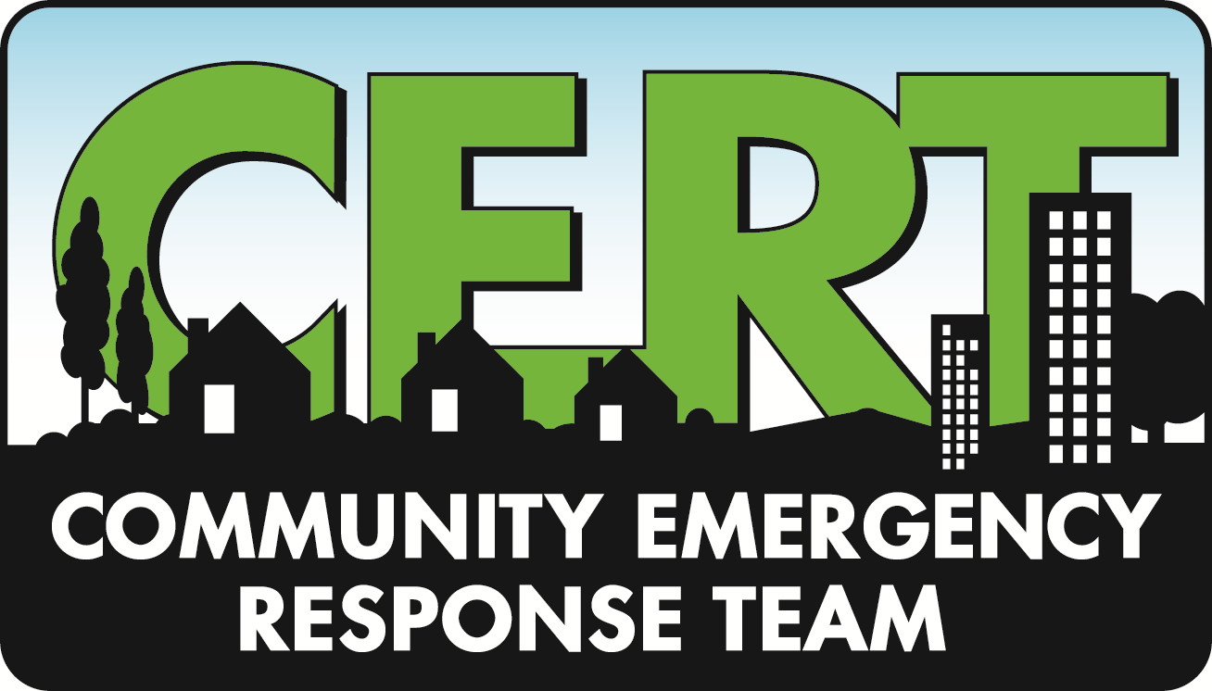
The Office of Emergency Management (OEM) is a local government department that provides for the health, safety and welfare of residents during times of emergency and disaster. Emergency Management has an active role in towns and cities nationwide, and focuses on municipal preparedness, response and recovery from all types of natural and man-made disasters. OEM managers work closely with local Fire Companies, First Aid Squads, Departments of Public Works, and Health Departments to coordinate activities and resources for maximum effectiveness.

There are several things you can do to be better prepared for an emergency. The Washington Township OEM encourages all residents to:

Plan Ahead
Create a family emergency plan based on what you’ve learned from previous events. Identify your needs and plan for them. Consider family members, pets, and the elderly in your plans. Consider combining resources with neighbors.

Stay Informed
Know how and where to get information. Familiarize yourself with available resources, explore helpful websites, and sign up for emergency alerts and notifications BEFORE you need them.

Be Prepared
Have nonperishable food, water, batteries, medicines, fuel, cash and a portable radio on hand. Have your utility service provider and insurance company contact information on hand. Keep vehicles fueled and serviced. If you have a generator, know how to use it safely. If you rely on well water, have a backup plan if it stops working.

What is OEM?
Plan Ahead
Stay Informed
Be Prepared

Washington

Township

Office of
Emergency Management
Questions?

Bruce Clark
Deputy OEM Coordinator
908-876-8314
bruce.clark@wtmorris-oem.org

Revised 7/2018

Emergency Awareness Guide

Office of Emergency Management
Get Involved

The Community Emergency Response Team (CERT) program helps train residents to be better prepared to respond to emergency situations in their communities. To volunteer as a local CERT member, you must complete an application and pass a background check.
For more information, visit www.citizencorps.gov/cert/ or contact Bruce Clark , Washington Township Office of Emergency Management. (contact phone and email listed below)

Twitter
Follow @WashingtonTwp on Twitter to receive updates from Washington Township.

Follow @WTPDMC to receive updates from the Washington Township Police Department.

Follow @MCUrgent to receive tweets from Morris County OEM on developments across Morris County.

FaceBook
Follow ‘Washington Township, Government, Long Valley’
Follow ‘Washington Township Police Department’

When critical emergency information need to be shared, Washington Township will utilize the RAVE System to issue alerts and notifications by phone to all residential and business with land line telephones. Landline numbers are added automatically. If you would like another number added (cell phone, work number, alternate contact) you may add that number at www.Smart911.com. Numbers associated with a VOIP service many not be automatically added, and should be added by residents.

Reverse 911 alerts

Receive Nixle alerts on your mobile phone
Washington Township also sends alerts by text message to mobile devices capable of receiving standard Short Message Service (SMS) text messaging. To sign up, send a text message containing the Washington Township zip code – 07853 – to address 888777.

Radio
Local radio station WRNJ is a valuable community resource in broadcasting timely information to the public. Tune in at 1510 AM, 104.7 FM, or 92.7 FM.

Additional Resources
Visit the township website:
www.wtmorris.net. Under the Departments Tab select Office of Emergency Management. You will find information about family disaster plans, useful links, CERT team information, and links to helpful publication and guides.

The American Red Cross
The website www.redcross.org contains helpful disaster plan information.

Wellness Check Program
The Washington Township Public Health Nurse works in conjunction with the Washington Township Police Department and OEM to identify and check in on seniors during emergency situations. Contact the Township Nurse, Gail Johnson at 908-876-3315 x1242 to sign up for the program.

JCP&L
Report power outages to 1-888-LIGHTSS (1-888-544-4877). or www.firstenergycorp.com. You can also report outages on the JCP&L Mobile App on your smart phone. Use the keyword ‘FirstEnergy’ when searching the app store. Make note of confirmation numbers you receive.

Local Websites
Washington Township’s website: www.wtmorris.net
is updated frequently during emergency situations.

The Long Valley Patch www.longvalley.patch.com
also provides timely information on their website and Facebook pages and allows you to sign up for email updates.

Ways to Stay Informed
Sign Boards
As we saw during Superstorm Sandy, technology-dependent communications may not be working. During an emergency, township employees will put regular paper updates on sign boards around town. The sign boards will be located at the following locations:

Municipal Building
Police Department
Schooley’s Mountain Fire House
Flocktown Road First Aid Squad Building
East Mill Road First Aid Squad Building
Long Valley Fire House
Fairmount Fire House St. Luke’s Church
Palmer Park
Heath Village

